GATE 0 - PROJECT SYNOPSIS
Themes 1-5 | System / Tool / Engine based Mini Projects

Expected length: about 4 pages + cover page
Team No. | 5
Theme No. | 1
Project Title | Persistent Key Value Storage Engine
Guide Name | Prof. Shrushti Gani
Team Members | 1.Pooja K D  2.Sakshi D S  3.Sukanya M S  4.Keerthana K

Student Preparation Instruction
This synopsis is intended to demonstrate the team's own understanding of the proposed project. Students should study the project, discuss within the team, consult relevant textbooks/technical resources, and prepare the content in their own words. AI tools shall not be used to generate the contents of this document.
At Gate 0, do NOT finalize: detailed functional/non-functional requirements, architecture/modules, algorithms/data structures, APIs, technology stack, alternate designs, detailed KPIs or test cases.
1. Background & Motivation
Briefly describe the proposed system/tool/engine, its purpose, broad functionalities/computational capabilities, and why developing it is technically meaningful as a Mini Project. Highlight opportunities to apply and integrate foundational Computer Science concepts.
The proposed project is a Persistent Key-Value Storage System for storing and retrieving data using key-value pairs. Unlike temporary storage, the system aims to preserve stored data even after the application is closed or restarted. It provides a practical understanding of data storage, retrieval, persistence. The project also gives an opportunity to integrate foundational Computer Science concepts from Data Structures, Operating Systems, Software Engineering, DAA, and Web Technology.
2. Project Objectives
State 3-5 broad engineering objectives. Describe what the team intends to develop or study. Do not prematurely prescribe architecture, algorithms, data structures, APIs or implementation mechanisms.
1. To develop a persistent key-value storage system for storing and retrieving data reliably._____________________________________________________________________________
2. To study and understand the fundamental concepts involved in data storage, retrieval, and persistence.______________________________________________________________________________
3. To provide a simple mechanism for managing and accessing stored key-value information._______________________________________________________________________________
4. To study the challenges related to data consistency, reliability, and efficient retrieval in a storage system._______________________________________________________________________________
5. To integrate relevant foundational Computer Science concepts in the development and study of the proposed system.______________________________________________________________________________

FOUNDATION COURSE INTEGRATION & CONCEPTUAL VIEW
Gate 0 - Themes 1-5

3. Foundation Course Integration
Identify at least three foundational courses that are expected to contribute meaningful technical depth. Mention only broad concepts/areas at this stage.
Sl. No. | Foundation Course | Broad Concepts / Areas Expected to be Applied | Role
1. | Operating Systems | File Management, Storage Management, Process Management | Dominant
2. | Data Structures | Data Organization, Searching, Efficient Access | Dominant
3. | Design Analysis of Algorithm | Searching, Updating, Operation Efficiency , Complexity analysis | Supporting
4. | Database Management System | CRUD operations | Supporting
4. Conceptual Workflow / System View
Draw one high-level block/workflow diagram showing the broad functional flow or major interactions in the proposed artefact. Keep it conceptual; detailed architecture, finalized modules, algorithms, data structures, APIs and technologies belong to later stages.
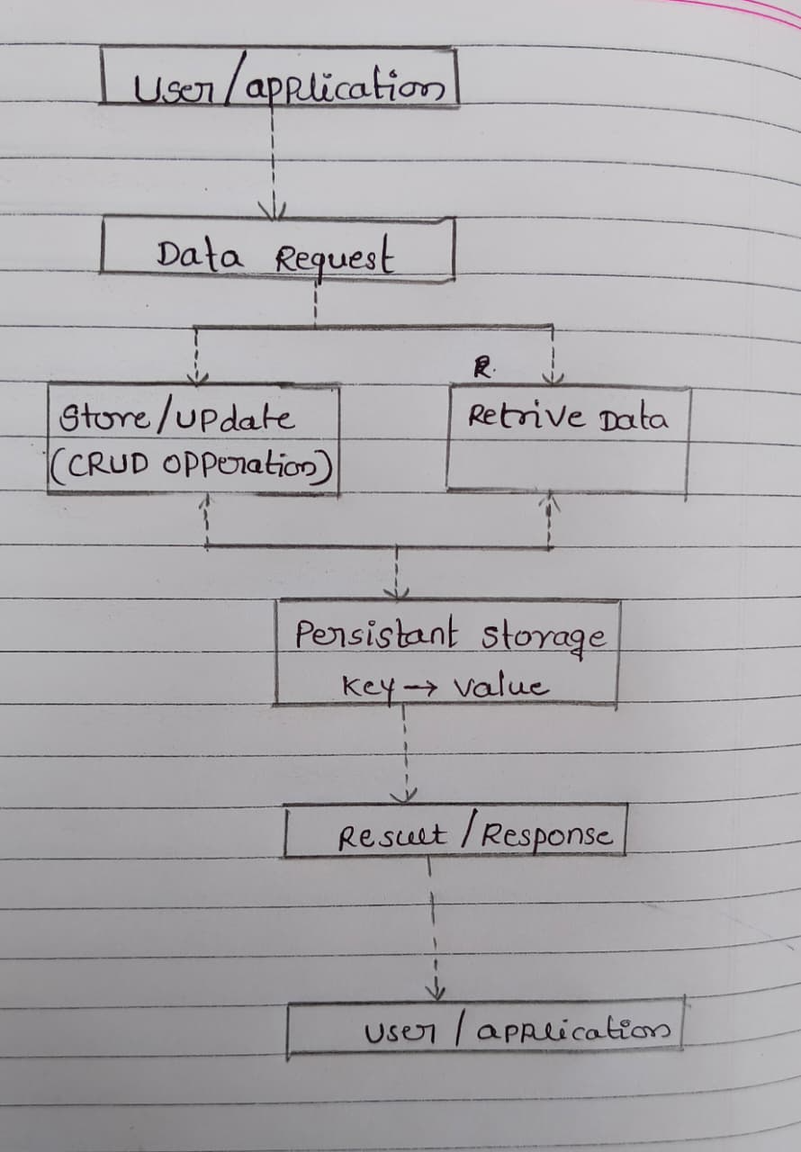

SCOPE & FEASIBILITY
Gate 0 - Themes 1-5

5. Broad Project Scope
Define the tentative technical boundary of the project. Detailed requirements will be derived later in S1.
5.1 Broadly In Scope
# | Broad In-Scope Item
1 | Storing key-value data persistently
2 | Retrieving and accessing stored data
3 | Updating and managing existing key-value information
4 | Maintaining data availability and consistency during storage and retrieval
5.2 Out of Scope
# | Out-of-Scope Item | Reason
1 | Large-Scale distributed storage | Beyond the scope of mini project
2 | Cloud -scale Deployment and management | Requires infrastructure beyond the current project scope
3 | Support for complex database operations | The project focuses on the key-value storage model
6. Feasibility & Constraints
Briefly assess whether the proposed scope is achievable as a 3-credit Mini Project. Identify required resources, prerequisite knowledge and major constraints. Existing libraries/tools may support peripheral functionality but should not completely hide the core mechanisms students are expected to design, implement and study.
Feasibility within 3-credit scope | The proposed system has a manageable scope for a 3-credit Mini Project  and can be developed incrementally while studying the underlying  storage and retrieval concepts
Required computing / resources | A standard computer, development environment, local storage, and basic testing resources are sufficient for the proposed project.
Prerequisite knowledge | Basic knowledge of Data Structures, Operating Systems, OOP, Algorithms, and programming fundamentals is required.
Major constraints / limitations | Limited development time, storage capacity
Use of existing libraries / tools | Existing libraries and tools may be used for supporting or peripheral tasks, while the core storage and retrieval concepts will be implemented and studied by the team.
Overall feasibility | Feasible with scope modification

INITIAL PROJECT RISKS & FACULTY REVIEW
Gate 0 - Themes 1-5

7. Initial Project Risks
Identify 2-3 major risks that may affect completion of the project and briefly state how the team plans to address them. These are initial risks and may be revised as the project evolves.
Sl. No. | Possible Risk | How will you address it?
1 | Data corruption or loss during storage or updates | Study storage reliability and include suitable validation and recovery considerations during development.
2 | Difficulty in maintaining data consistency  Clearly define how stored information should remain consistent and verify it during development. | Study retrieval performance and consider efficiency during the design and development stages.
3 | Lack of sufficient knowledge of storage-system concepts | Refer to textbooks, technical resources, and course concepts and discuss technical issues within the team
. Gate 0 - Faculty Review
☐ Technical motivation and objectives are clear.
☐ At least three foundation courses show potential for meaningful technical depth.
☐ Conceptual workflow/system view clearly communicates the proposed artefact.
☐ Broad scope is appropriate for a 3-credit Mini Project.
☐ Core mechanisms can be designed/implemented rather than fully hidden by ready-made tools.
☐ Feasibility, constraints and initial risks are reasonably identified.
Decision: ☐ Approved ☐ Approved with Modifications ☐ Resubmit
Faculty Remarks:
________________________________________________________________________________
________________________________________________________________________________
________________________________________________________________________________
Guide Signature: ____________________________ Date: __________________

